TRIP NAME HERE

10th – 12th September 2020

Participants | Member No. | Vehicle Details
Name (TL) | 0000 | Pajero
Trip Summary
Provide a quick summary and overview of the trip including the location.
Distance & Route
Provide some information relating to the estimated distance travelled & recommended route.
Fuel & Supplies
Provide some information as to the availability of fuel & supplies.
Difficulty Level / Vehicle Requirements
Easy / Medium / Difficult – Provide some brief information as to vehicle requirements and potential challenges or hazards. E.g. Requires minimum 2 inch lift, mud tyres and winch.
Tips, Notes and Special Remarks
Provide all other relevant information such as accommodation requirements, suitability for caravans or campers, permit requirements, best times to travel, preferred maps, things to do, weather expectations, and so on.

Trip Detail

Day 1 – Fiday 10th September
We began our trip with a hardy breakfast at the award-winning bakery in the lovely town of Mitsubishi. From here we aired down and immediately hit the dirt tracks. Travelling in convoy towards Pajtown, we came across a vast array of birdlife amongst the lakes on the side of the road including the elusive Mongolian racing pigeon.
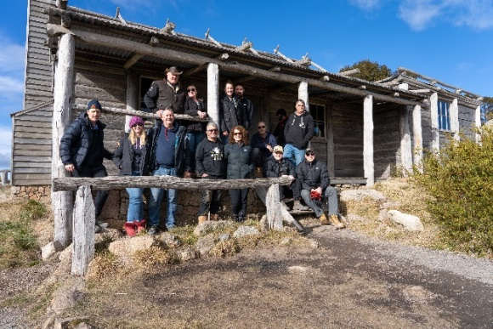 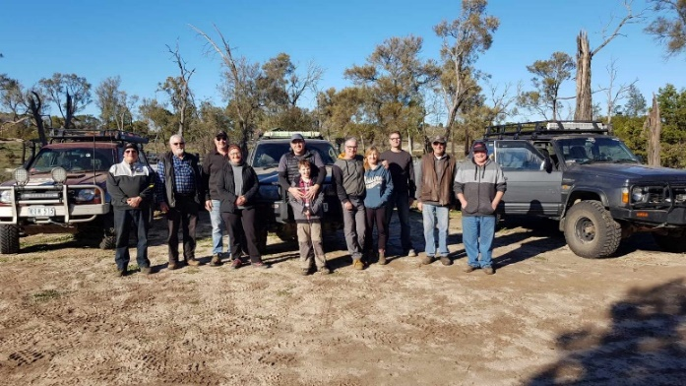
“Photo Description 01 “Photo Description 02”

Day 2 – Saturday 11th September
A few members stayed up quite late the night before enjoying a few social drinks and plenty of laughs. As a result, there was a bit of a slow start to day two of our trip. There was plenty of sunshine at least which was great as it gave our gear a good chance to dry out from the morning dew. Well the cars and caravans were packed and off we went with the view of making it to the Prado Shire for lunch.
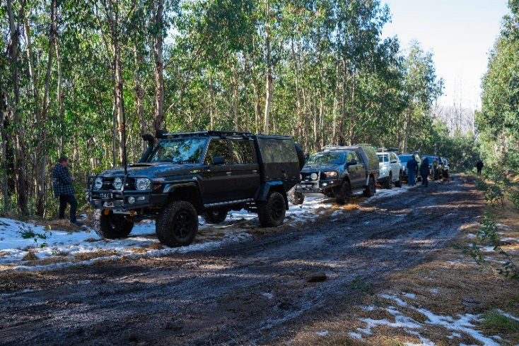
“Photo Description 03”

Day 3 – Sunday 12th September
Knowing we had a full day’s drive ahead of us, members were up early this morning. Packed and ready to go by 7am, we headed to the town of Triton for breakfast. Lucky for us, renowned chef, Mr Bishi was holding a fund raiser at the local butchers cooking up his famous Pajwurst sausages. What a treat! Some of our members even got to sample his world famous sausage with the locally produced Chally sauce. Once lunch was over, we got back in convoy and made our way back home. Making it just in time for ‘fivesies’.
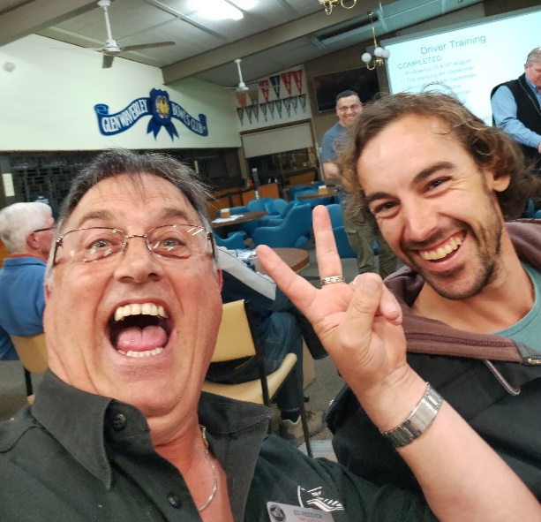
“Photo Description 04”

Finish with member’s Name & number for POTY points.
Rusty Patrol #0001

